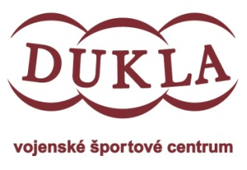
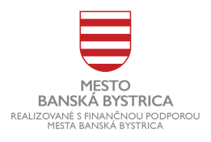
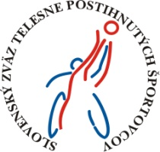
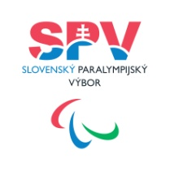

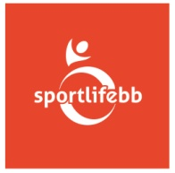
HANDI OPEN 2025 TEAM MANUAL

Organizátor: ŠK SPORTLIFE BB, Jana Sučíková
When : 16.8.2025
Where: Štadión SNP, Cesta olympionikov 3, 974 04 Banská Bystrica
Start: 9:30
Participants Categories : F10,30,40,50,60
Disciplines: discus, shot put, javelin, club throw, Each athlete can compete in a maximum of two disciplines.
Travel expenses : not provided by the organizer
Accomodation: not provided by the organizer
Visa: not provided by the organizer
Important Limitation: Due to organizational capacity, the event is limited to participants from European countries only
Starting fee : 30,- eur/ athlete
Rewards: Medals
Events: All events are opened in case that at least 2 athletes are registered. Medals to be awarded only for events with at least 3 athletes. Athletes allowed in classes F10-30-40-50-60
The competition is sanctioned, it will take place according to the valid athletics rules with the participation of qualified referees. Only athletes with a valid international classification can participate. The results will be calculated according to RAZA. The use of your own equipment will be possible after checking by the organizer. Throwing structures and equipment must meet the parameters of rules 35 and 36.

Confirm your participation no later than 10.7.2025 by sending a completed application to the email: sportlifebb@gmail.com then we will be sent an invoice for the entry fee, which must be paid no later than 16.7.2025 Later applications will not be accepted.
Conclusion:
All participants have the duty to observe safety regulations and other regulations of the organizer. The organizer reserves the right to make changes in the schedule.
We look forward to seeing you.

